Group Name Java GROUP

Project Title CALCULATOR APP

IJENMOR ALEX MICHAEL

BHU/22/04/09/0102

SOLOMON EZIJOTA ENITIE

BHU/22/04/09/0018

ANOINTING SUNDAY ISTIFANUS

BHU/22/04/10/0021

ELISHA NKOSI AWOTU

BHU/22/04/09/0071

ABDULHAMID ABDULLAHI

BHU/22/04/09/0038

Project Description and Screenshots

It is a calculator app which solves simple mathematical problems like addition, subtraction, multiplication and division. The app was created using java for it.

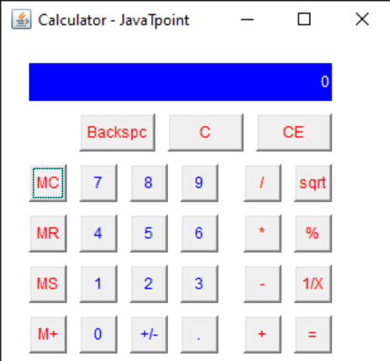

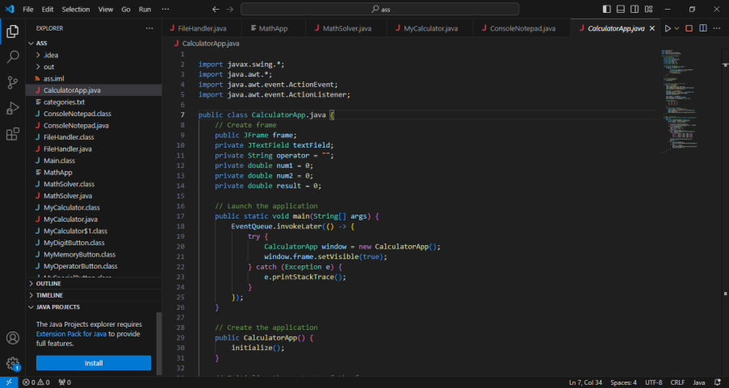

IJENMOR ALEX MICHAEL

BHU/22/04/09/0102

He is the group leader and head developer of the project, he started with research and started with work on the project

SOLOMON EZIJOTA ENITIE

BHU/22/04/09/0102

He also helped with research and development of the project and also bringing critical knowledge of the project which help us to further the project.

ANOINTING SUNDAY ISTIFANUS

BHU/22/04/10/0021

He helped in making the calculator app and also did the implementation of the class special button.

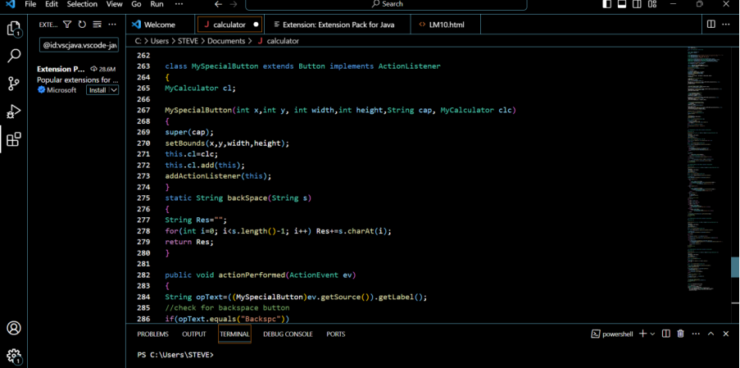

Here is the special class button.

ELISHA NKOSI AWOTU

BHU/22/04/09/0071

He was part of the development and research party of the group who has a broad knowledge of the project and was instrumental in it’s completion.

ABDULHAMID ABDULLAHI

BHU/22/04/09/0038

He provided network access and was also instrumental in the development of the project, he also provided ideas and research on how we can complete the project.

Screenshot of Github Contribution Page for the project

